MOVIE RECOMMENDATION

Cosine similarity is the cosine of the angle between two n-dimensional vectors in an n-dimensional space. It is the dot product of the two vectors divided by the product of the two vectors' lengths (or magnitudes).

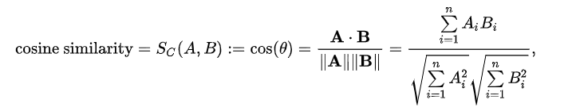

Example
from sklearn.metrics.pairwise import cosine_similarity
vec1 = [1,1,0,1,1]
vec2 = [0,1,0,1,1]
print(cosine_similarity([vec1, vec2]))

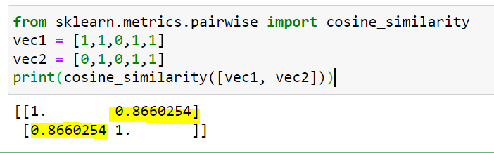

vec1 * vec2 = 1*0+1*1+0*0+1*1+1*1 = 0+1+0+1+1= 3
SQRT(1*1+1*1+0*0+1*1+1*1) = SQRT(1+1+0+1+1) = SQRT(4) = 2
SQRT(0*0+1*1+0*0+1*1+1*1) = SQRT(0+1+0+1+1) = SQRT(3) = 1.73

Cosine Similarity = 3/ (2*1.73) = 3/ 3.46 = 0.8670

Import Libraries
import numpy as np
import pandas as pd
import difflib
from sklearn.feature_extraction.text import TfidfVectorizer
# TfidfVectorizer - This is used to convert text data into numerical values
from sklearn.metrics.pairwise import cosine_similarity
import os

Check the current working directory

display (os.getcwd())

Change the current working directory and read data

os.chdir('C:\\Noble\\Training\\Acmegrade\\Data Science\\Projects\\PRJ Movie Recommendation\\')
movies_data =pd.read_csv('movies.csv')
display (movies_data.head())

Display the shape
display (movies_data.shape)

Selecting the relevant features for recommendation
selected_features = ['genres','keywords','tagline','cast','director']
print(selected_features)

Display the info
display (movies_data.info())

Check for Null Values
display (movies_data.isna().sum())

Display the selected columns
display (movies_data[selected_features].head())

Check Null Values in selected columns
display (movies_data[selected_features].isna().sum())

Replacing the null values with null string

for feature in selected_features:
movies_data[feature] = movies_data[feature].fillna('')
display (movies_data.head())

Check Null Values in selected columns
display (movies_data[selected_features].isna().sum())

Combining all the 5 selected features

combined_features = movies_data['genres']+' '+movies_data['keywords']+' '+movies_data['tagline']+' '+movies_data['cast']+' '+movies_data['director']
display (combined_features)

Converting the text data to feature vectors/Bag of Words
This is to find cosine similarity
# Vector shape is (4803, 17318). This is based on the number of distinct words. All the words will be converted to their equivalent numbers.

vectorizer = TfidfVectorizer()
feature_vectors = vectorizer.fit_transform(combined_features)
display (feature_vectors.shape)
display (pd.DataFrame(feature_vectors.toarray()))

Print TF-IDF Values
TF-IDF stands for Term Frequency Inverse Document Frequency of the records. It can be defined as calculating how relevant a word in a series or corpus is to a text.

TF-IDF (Term Frequency-Inverse Document Frequency)
Term Frequency: In Document d, the frequency represents the number of instances of a given word t
tf(t,d) = count of t in d / number of words in d
Inverse Document Frequency
idf (t) =1 + log _{e} [ n / df(t) ]
where
n = Total number of documents available

t = term for which idf value has to be calculated
df(t) = Number of documents in which the term t appears

TF-IDF = tf(t, d) * idf(t), (Multiply tf and idf values)
The sklearn calculated TF-IDF values might not match with Manually calculated values since smoothing and l2 normalization are applied in Sklearn calculated values

print (feature_vectors)

Getting the similarity scores using cosine similarity
similarity = cosine_similarity(feature_vectors)
print (similarity )

Print Shape Cosine Similarity

display(similarity.shape)

Enter the movie name to get Similarity
movie_name = input(' Enter your favourite movie name : ')

Creating a list with all the movie names given in the dataset

list_of_all_titles = movies_data['title'].tolist()
print(list_of_all_titles)

Length of the List
print (len(list_of_all_titles))

Finding the close match for the movie name given by the user

find_close_match = difflib.get_close_matches(movie_name, list_of_all_titles)
print(find_close_match)

Display the close match
close_match = find_close_match[0]
print(close_match)

Finding the index of the movie with the title
index_of_the_movie = movies_data[movies_data.title == close_match]['index'].values[0]
print(index_of_the_movie)

Get the similarity row for the selected index
These are the similarity values for the movie entered by the user
similarity_score = list(enumerate(similarity[index_of_the_movie]))
print(similarity_score)

Length of Similarity Score
len(similarity_score)

Sorting the movies based on their similarity score
Display the index and similarity rating as a tuple
This list is sorted based on the similarity score

sorted_similar_movies = sorted(similarity_score, key = lambda x:x[1], reverse = True)
print(sorted_similar_movies)

Print the name of similar movies based on the index – Top 30

print('Movies suggested for you : \n')
i = 1
for movie in sorted_similar_movies:
index = movie[0]
title_from_index = movies_data[movies_data.index==index]['title'].values[0]
if (i<30):
print(i, '.',title_from_index)
i+=1

Consolidated code
movie_name = input(' Enter your favourite movie name : ')

list_of_all_titles = movies_data['title'].tolist()

find_close_match = difflib.get_close_matches(movie_name, list_of_all_titles)

close_match = find_close_match[0]

index_of_the_movie = movies_data[movies_data.title == close_match]['index'].values[0]

similarity_score = list(enumerate(similarity[index_of_the_movie]))

sorted_similar_movies = sorted(similarity_score, key = lambda x:x[1], reverse = True)

print('Movies suggested for you : \n')

i = 1

for movie in sorted_similar_movies:
index = movie[0]
title_from_index = movies_data[movies_data.index==index]['title'].values[0]
if (i<30):
print(i, '.',title_from_index)
i+=1

